How can you help your child in literacy?
-Ask your child specific questions about what they read.
-Encourage children to read, then write and speak about, nonfiction text such as newspapers, magazines, and biographies.
-Encourage children to research topics of interest and read series that relate to a central topic.
-Have your child follow step by step instructions or a set of directions in order to accomplish a task, such as building a sandcastle or operating a game.

How can you help your child in math? 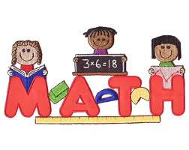
-Help children practice their addition, subtraction, multiplication and division facts.
-Encourage children not to give up while solving problems, to build stamina and develop their critical thinking skills. Don’t give them the answers - ask them to think of different ways they can solve problems.
-Have children illustrate the math they were thinking in their head and discuss it out loud.
-Have children apply their math knowledge to a real-world scenario at home, such as doubling a recipe or calculating the area of a room.

Common Core Information for Parents

